
Integrated Programme in Management (IPM)
IIM Rohtak
IT Applications
Hybrid Machine Learning for Food Delivery Time Optimization
Submitted by: Gaurav Porwal
Roll Number: IPM06020
Date: 13th March 2025
Submitted to: Dr. Karan Verma

Introduction
The rapid growth of online food delivery platforms, including Swiggy, Zomato, and Uber Eats, has augmented the necessity of efficient logistics systems that will deliver the products on time. A significant problem with these platforms is the correct forecast of delivery time.
Delivery time depends on many factors such as traffic, weather, distance to be covered when delivering, type of vehicle used and experience of the driver. These conflicting elements complicate the prediction process, and incorrect estimates may lead to wasted time, dissatisfaction, and inefficient use of delivery assets.
Machine learning is useful in solving logistics prediction tasks. But the reason is that, in traditional supervised models, the hidden patterns in the delivery environment might be missed. To solve this, this paper suggests a hybrid machine learning model in which unsupervised clustering is integrated with supervised prediction models in order to enhance the accuracy of delivery time.
Problem Statement
Food delivery companies often incur unpredictable order fulfillment times because of various external and operational issues. Delay, weather unpredictability, the distance covered to deliver, and the performance of the drivers are major determinants of the delivery time. Inaccurate delivery estimates can lead to a lack of trust in the platform and the corresponding customer increases in cancellations and a poor user experience.
Operation-wise, inaccurate predictions also impact driver allocation, routing, and logistics planning. The majority of conventional prediction systems use only supervised learning techniques and can ignore the alternative operation patterns in the data. Thus, an extra-smart system is required that will be able to scan the environment of delivery and generate more accurate predictions of delivery times.
Objectives
The primary aim of this project is to create a hybrid machine learning system that is going to enhance delivery time prediction. The specific objectives are:
- To examine the food delivery data and reveal the factors that have a significant impact on delivery time.
- To find the concealed delivery patterns with the help of unsupervised learning methods.
- To construct predictive models on delivery time through a supervised learning algorithm.
- To combine the findings of clustering into prediction models to enhance performance.
- To understand the performance of various machine learning algorithms.
Dataset and Feature Description
The dataset used in this study consists of historical food delivery records and features which are obtained from the Zenodo repository. It includes multiple variables like variables related to drivers, environmental conditions and delivery characteristics.
The target variable in the dataset is Time_taken (minutes), which represents the total delivery time.
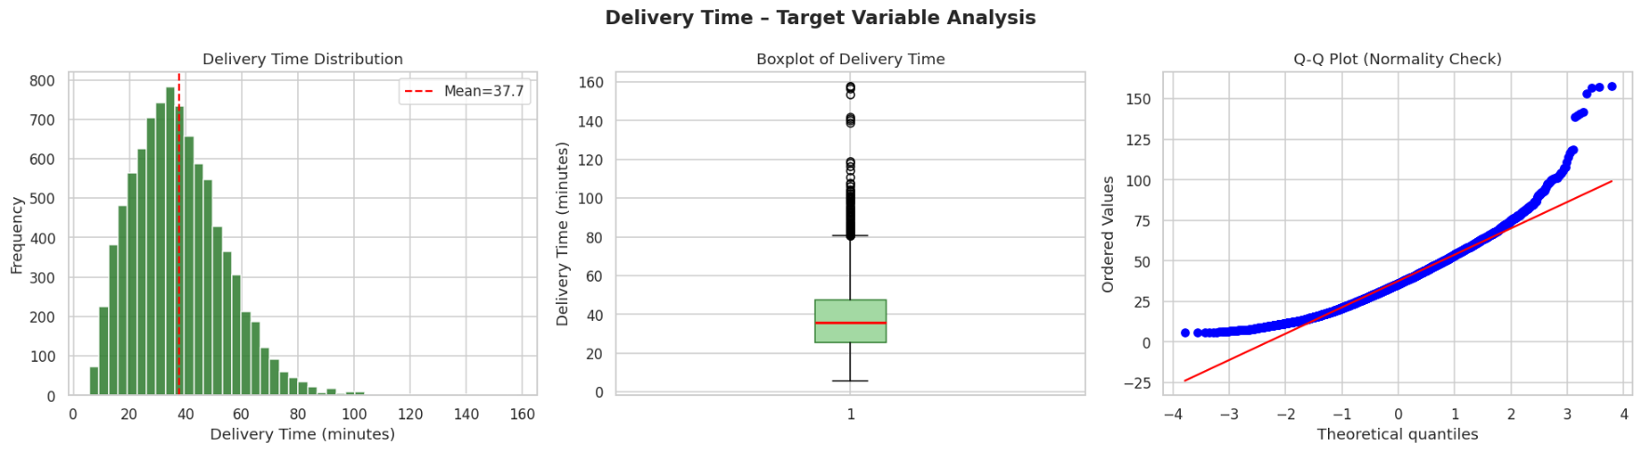
Table 1: Key Features Used in the Study
Feature Category | Variables | Description
Driver Features | Age, Ratings, Experience | Characteristics of delivery drivers
Environmental Features | Weather, Traffic Density, City | External conditions affecting delivery
Delivery Features | Distance, Vehicle Type, Order Type, Multiple Deliveries | Operational delivery attributes
Target Variable | Time_taken | Total delivery time in minutes

Data Preprocessing:
A number of preprocessing steps have been carried out prior to the application of machine learning algorithms in order to guarantee the quality of data and enhance the performance of the model.
Handling Missing Values: Rows with missing values were dropped to ensure uniformity in the data.
Presentation of Categorical Variables: Nominal characteristics like type of vehicle, weather condition and type of order were coded into numbers.
Feature Scaling: The numerical characteristics, like distance and the density of traffic, were normalized so that all variables play an equal role when training the model.
Feature Engineering: A distance/traffic density interaction feature was developed. This property aids in the attainment of the joint effects of distance and congestion on the delivery time.
Methodology
This study has a hybrid machine learning methodology comprising two broad steps:
1. Delivery pattern discovery Unsupervised learning.
2. Guided learning to make a prediction of the delivery time.
The overall workflow is shown below:
Dataset → Data Preprocessing → Clustering → Cluster Label Feature → Supervised Learning → Delivery Time Prediction
This mixed framework enables the model to first learn the concealed delivery settings after which it utilizes such insights to enhance the accuracy of its predictions
Unsupervised Learning: Delivery Pattern Discovery
Unsupervised learning techniques were used to identify natural groupings within the delivery dataset. The first algorithm applied to this stage was the K-Means Clustering.
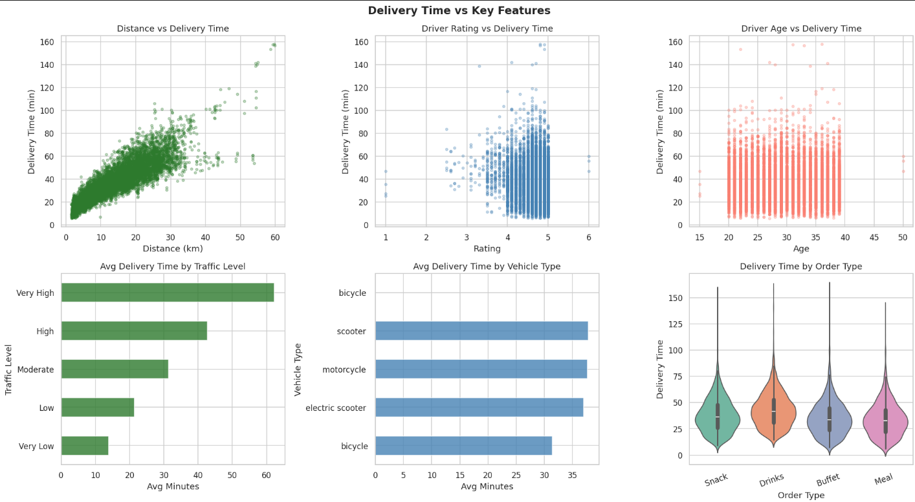
K-Means divides the similar delivery records using feature similarity. The variables that the algorithm utilized in this project included distance, traffic density, weather patterns, vehicle type, and ratings of the delivery persons to identify the clusters. The steps of the clustering process were the following:
1. Standardizing pertinent features.
2. The Elbow Method was used to arrive at the best clusters.
3. Using the K-Means algorithm.
4. Labeling of the cluster of delivery records.
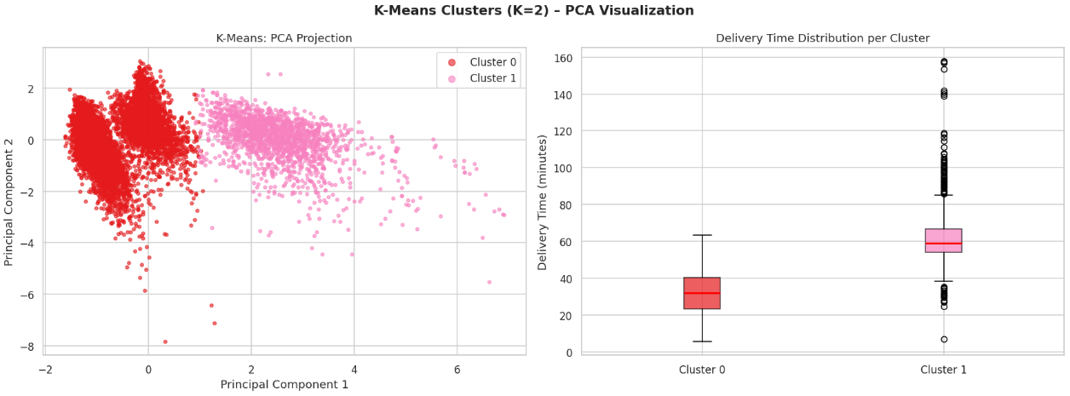
Example delivery clusters include:
- Short distance with low traffic resulting in faster deliveries.
- Medium distance with moderate traffic.
- Long distance with heavy traffic leading to slower deliveries.
Supervised Learning: Delivery Time Prediction
Upon locating the patterns of deliveries, they were applied to supervised machine learning models, which forecasted the delivery time. The data was separated into training and testing.
Training Data: 80%
Testing Data: 20%
Three supervised learning algorithms were used.
Linear Regression
It is used as a baseline model because it is easy to understand and interpret.
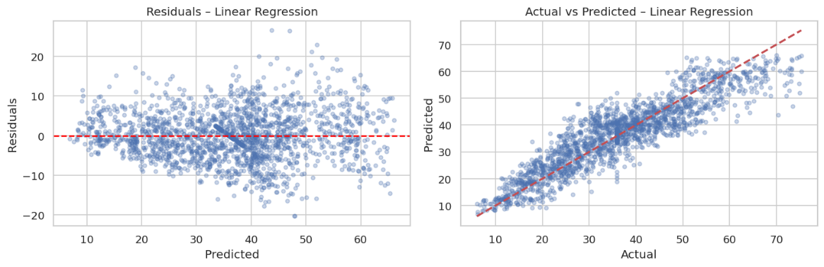Random Forest
An ensemble learning algorithm that constructs many decision trees and makes a combination of their predictions to enhance the accuracy.
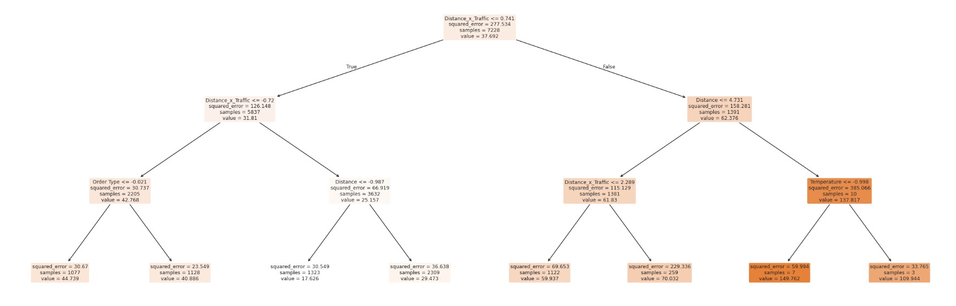
K-Nearest Neighbors (KNN)
Makes predictions about the time of delivery through comparison with other previous delivery records.
Examples of features of the models include distance, density of traffic, weather, type of vehicle, ratings of deliveries and labeling of clusters.
Model Evaluation
Model performance was evaluated using standard regression metrics.
- Mean Absolute Error (MAE)
- Root Mean Squared Error (RMSE)
A smaller value of these measures implies higher accuracy of prediction.
Table 2: Comparison of Machine Learning Models
Model | Strength | Weakness
Linear Regression | Simple and interpretable | Cannot capture complex relationships
Random Forest | Handles nonlinear patterns and feature interactions | Computationally heavier
K-Nearest Neighbours | Works well with similar data points | Sensitive to noise and large datasets
Random Forest offers more effective performance as compared to the other tested models since it has the ability to capture more complex relationships among the variables.
Hybrid Model Architecture
The hybrid machine learning model combines the models of prediction and clustering.
Step 1: K-Means clustering is used to recognize patterns of deliveries.
Step 2: A new feature in the dataset is added as cluster labels.
Step 3: Supervised models are the models where both original features and cluster labels are utilized to predict delivery time.
Such a structure helps to increase the accuracy of prediction since the model is aware of the kind of delivery environment of each order. 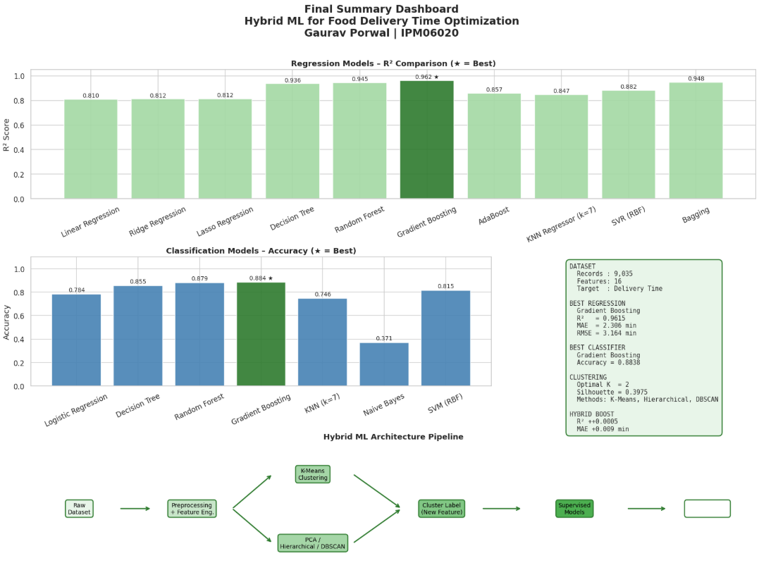
Social Impact
A number of positive impacts can be generated by the proposed system.
Reducing Food Waste
Proper prediction of delivery enables making sure that the food is delivered to the customers in time, when it is still fresh, leading to fewer orders being cancelled and food being wasted.
Improving Driver Welfare
Improved prediction systems will allow the fair allocation of workloads among drivers and lessen stress and enhance safety within the gig economy.
Limitations
Although its outcomes are promising, there are various limitations. The data can be that of restricted geographic areas. Conditions of traffic may vary dynamically. Weather information was reduced to form many categories. The significant variables, like restaurant preparation time and GPS route information, were omitted.
These limitations can be overcome in future work with the use of real time traffic information and bigger datasets.
Conclusion
This shows that a hybrid machine learning approach can be used to predict the delivery time of food with the help of unsupervised and supervised learning methods. Clustering aids in determining the concealed patterns of deliveries, whereas the supervised models employ the patterns to make more precise forecasts.

Random Forest is one of the algorithms that were tested and is accurate because of its capacity to model multifaceted associations among the variables. The suggested hybrid solution will be able to facilitate real-time delivery prediction, enhanced driver assignment, and more effective logistics of food delivery platforms.
As this system continues to improve (through the integration of real-time data and improved machine learning models), it can greatly augment the delivery processes in the food delivery sector.

